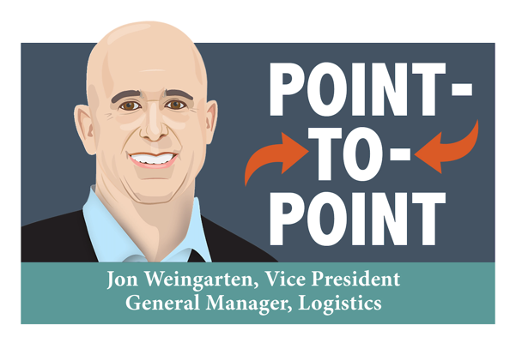

**For the want of a truck driver….**

January 2022

For want of a nail…

For want of a nail the shoe was lost.

For want of a shoe the horse was lost.

For want of a horse the rider was lost.

For want of a rider the battle was lost.

For want of a battle the kingdom was lost.

All for the want of a nail.

Benjamin Franklin

Logistics is all about detail. A lost nail can indeed derail shipping plans. This raises the question: What are the implications of the current trucker vaccine mandate on Canadian business and consumers? Should we be concerned?

The Canadian Trucking Alliance estimates as many as 32,000 Canadian and American cross-border truck drivers may be taken off the roads due to the mandates. This represents 20% of the total. The industry was already short 23,000 drivers before the mandate. Truckers facilitate Canadian imports of $21B of food from the USA annually, 70% of which crosses the border by truck. The sector faces a lack of available drivers, trucks and trailers, increasing costs for shippers and making it more difficult for carriers to haul more freight.

**IMPLICATIONS**

1. Carriers are in even shorter supply, temporarily. Freight rates remain high.
2. Food shortages? There is no need to panic, and no need to stockpile, although there are temporary disruptions and empty shelves. The key word is temporary.
3. Price increases will be necessary to offset the increased cost of goods. Inflation was 4.8% in Dec 2021, a 30 year high. Economists say that the biggest risk in 2022 is inflation. Will the global economy be robust enough to get by with less help from governments and central banks? Will inflation be a temporary by product of COVID, or a more persistent problem?

**WHAT CAN SHIPPERS DO?**

1. **Trust and collaborate with your 3PL partner.** As a 3PL we have many options available as we work with over 300 partners worldwide. We will recommend only actions that are in your best interests. As a trusted partner who shares your business goals, we have a vested interest in your success.
2. **Expect your logistics provide**r **to think, talk and act like an extension of your staff.** Collaborate with your 3PL. Their core competency is logistics; the more they can contribute, the more you stand to gain in dollar savings, on-time performance, and effective risk management.
3. **Over-communicate with partners.** Good communication makes for strong collaboration. What are your goals, priorities, back-up plans? Constantly drive transparency of your messaging with partners throughout the supply chain. Plan ahead as space is still limited and rates are still high.
4. **End-to-end solutions for brokerage and logistics can minimize delays, improve accuracy, tracking and tracing, and visibility, while providing 24/7 access, better document creation and reports. End-to-end solutions may be more cost-efficient, as well.**

**If your logistics team is stretched, consider partnering with us. It’s our core competency. We can supplement your corporate knowledge and expertise,**

**and offset a labour or talent shortage.**

[logitsics@willsonintl.com](mailto:logitsics@willsonintl.com) or call 1 866 945 5378.

