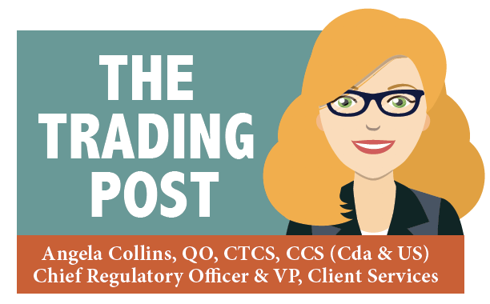

**Brian Barber Appointed To CBP Committee**

**World Customs Organization Updates Harmonized System**

**CARM Release 2 Update**

February 9, 2022

# **U.S. Customs & Border Protection Announces Members of the 16th Term of the Commercial Customs Operations Advisory Committee (COAC)**

The CBP has appointed Brian Barber, our Director, U.S. Brokerage Operations and Government Affairs, to the Commercial Customs Operations Advisory Committee (COAC). The COAC role is to advise Treasury and Department of Homeland Security on all matters of CBP commercial operations.  The committee is comprised of trade lawyers, importers, customs brokers and senior customs officials

I cannot tell you how proud I am of Brian for this accomplishment. We congratulate all the COAC members. Below is the CBP announcement.

Mr. Brian Barber, a licensed customs broker and certified customs specialist, serves as Director, U.S. Brokerage Operations and Government Affairs at Willson International Inc. With over 24 years’ industry experience, he is the qualifying officer supporting the corporate license and national permit of the organization.  As part of a medium sized Canada – United States brokerage and logistics company, Mr. Barber has unique insight into trade issues, particularly trade with Canada at northern border ports of entry.

In addition to overseeing corporate compliance and formal reviews, Mr. Barber is responsible for ensuring the highest possible standards of staff training, development, and operational efficiency.  Leading the company in the development and implementation of integrated solutions, he has played a key role in partnering with software providers to meet evolving regulatory requirements and provide solutions that benefit both Willson International and its customers.

Mr. Barber spent a year with the National Customs Brokers and Forwarders Association of America Washington, DC, overseeing industry-specific education.  He remains active in leadership roles for several trade associations and continues to be engaged in various U.S. Customs and Border Protection and Partner Government Agency working groups.

**World Customs Organization: Major Changes To Harmonized System**

Approximately every five years the World Customs Organization (WCO) updates the Harmonized System (HS). Member countries (including Canada and the USA) are responsible for updating their own country’s tariffs. Customs (both Canada Border Services Agency and U.S. Customs and Border Protection) advised industry of the impact of the additions, revisions, and deletions to their respective Customs Tariff(s) during the last quarter of 2021.

The new HS 2022 edition makes some major changes to the Harmonized System, covering a wide range of goods moving across borders. There were approximately 350 amendments affecting 5600 tariff classification numbers, for the 2022 WCO Tariff.

Approximately 3.5 million-part numbers required review. Based on the revisions to the Customs Tariff and client outreach, tariff databases were updated as required: Chemicals (58); Wood (31); Textiles (21); Base Metals (27); Machinery (63); Transport (22); Other (52). This involved 1228 headings identified by the first four digits, 5612 subheadings identified by the first six digits, and thousands of 10-digit tariff changes for both Canada and the US.

The scope of the updated Tariff resulted in multiple existing HS tariff classification numbers breaking out into multiple new HS tariff classification numbers.

Willson International has proactively reviewed your database and analyzed PGA requirements resulting from the published changes. It is also recommended that previous tariff rulings are reviewed for accuracy and new rulings requested when applicable.

' .

**CARM Release 2 Update & CARM Webinars**

Canada Border Services Agency (CBSA) has advised that the CARM Release 2 (May 2022) is being delayed. It will likely happen in January 2023. A written confirmation is pending. The CARM Trade Chain Partner Working Group also confirmed that there will be a “Client Experience Simulation (CES)” project that kicks off in May 2022. No details were provided. We will advise customs as soon as this is confirmed.

**Update On CARM Webinars**

The CBSA’s Assessment and Revenue Management (CARM) team is continuing monthly webinars. These webinars will continue to focus on the steps for CARM Client Portal Onboarding.

Registration is required for these webinars. Please register using the link that corresponds to your preferred date/time.

**Webinar Registration- CARM Client Portal Onboarding**

|  |
| --- |
|  |
| **English**  Tuesday, February 15th, 2022 | 1:00pm – 2:30pm EST | [Registration Link](https://canada.webex.com/canada/j.php?RGID=r18b50d664ab85f53c7372ec48038f26b) |  |
| Tuesday, March 22nd, 2022 | 1:00pm – 2:30pm EST | Registration Link |  |
| **French**  Tuesday, February 15th, 2022 | 3:00pm – 4:30pm EST | [Registration Link](https://canada.webex.com/canada/j.php?RGID=rd12064291c4125f2e8c1105b9b03ebf1) |  |
| Tuesday, March 22nd, 2022 | 3:00pm – 4:30pm EST | [Registration Link](https://canada.webex.com/canada/j.php?RGID=r4a81137b3337ac74d9b483f8c0e9872f) |  |
|  |  |  |  |



[**willsonintl.com**](http://willsonintl.com/)

[**service@willsonintl.com**](mailto:service@willsonintl.com)